Lab Objective

Learn how to Use Administrative Template

**Lab Procedures**

**1.** On RWDC01, with Server Manager, click Tools > Group Policy Management. The Group Policy Management console opens.

**2.** Navigate to and click the Group Policy Objects container.

**3.** Click the Delegation tab.

**4.** To specify who can create GPOs, click Add. When the Select User, Computer, or Group dialog box opens, type **John Smith** and click OK.

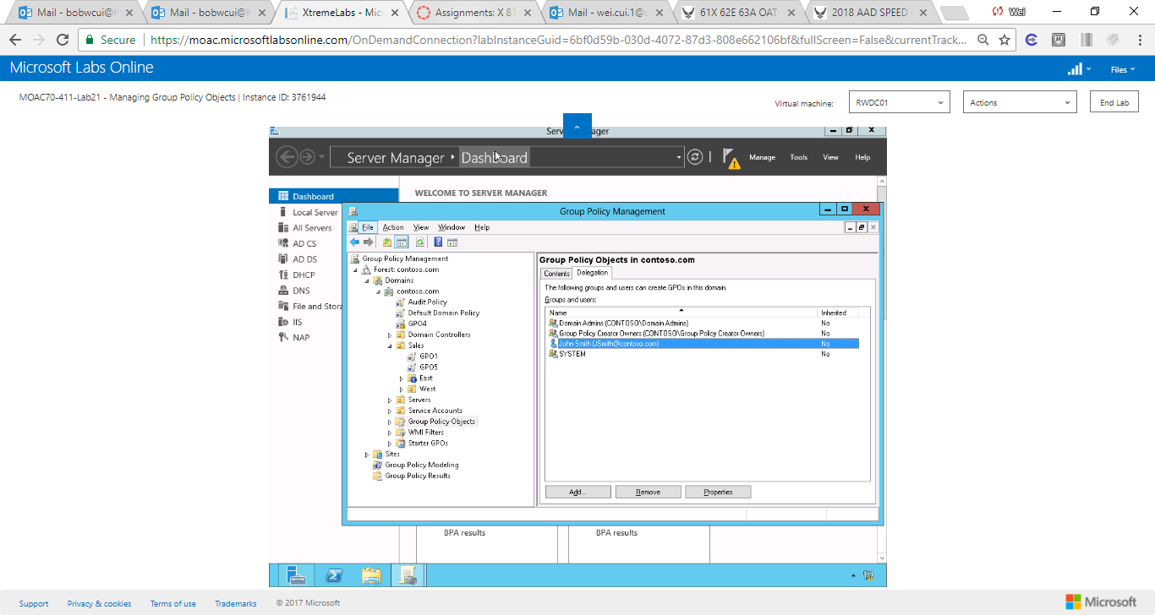

Figure John Smith is added to the group who can create GPOs.

|  |  |
| --- | --- |
| Question 4 | A user creates a GPO. What do you need to do for that user to manage his or her GPO that he or she created? |

**5.** To specify who can manage an individual GPO, for example, GPO7, click GPO7. Then click the Delegation tab.

**6.** To add a user or group, click Add. When the Select User, Computer, or Group dialog box opens, type **John Smith** in the Enter the object name to select text box and click OK.

**7.** When the Add Group or User dialog box opens, set permissions to Edit settings, delete, and modify security and click OK.

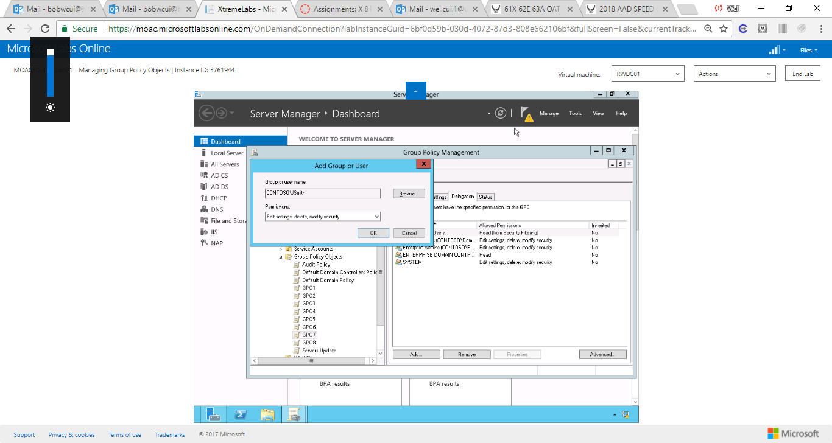

Figure John Smith is given the permission to edit GPO7.

**8.** Close the Group Policy Management console.

**Lab Summary**

During this exercise, you configure the desktop wallpaper and screen saver settings. The screen saver settings are used to help protect a system by activating a screen saver when a user walks away from his or her computer for more than 15 minutes. If the screen saver is activated, the user will have to input his or her password to resume.